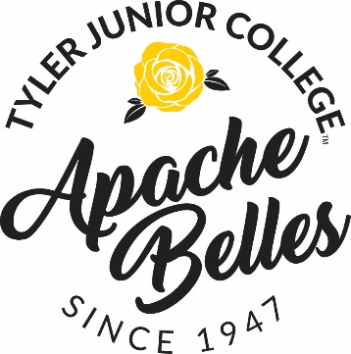
June Audition Schedule
Saturday June 22nd : (you may wear any color Sports bra with black hot shorts, pretty makeup and hair- that will stay out of your face and footwear of your choice). Preliminary auditions will be held in Gentry gym located in the Band, Apache Belles and Dance Building / Those who have attended Pow Wow Camp MUST be present to learn preliminary combos.
12:30pm-1:00pm. - Registration
1:00pm. - Welcome and Stretching in Gentry Gym then begin Preliminary Auditions
1:30-2pm (approximately) Preliminary Cuts
2pm. - Begin combinations in Apache Belle Studio (if space allows)

3:00pm – Conduct Fitness Assessment
3:30 pm - (approximately)- Begin Interviews and work through audition process with Assistants and to conduct individual interviews.
*Dismissed once your interview has been completed
Sunday, June 23rd : (Bring an outfit that is proper for your formal introduction to the Directors and the Sophomore Apache Belles)- something nice and put together that showcases your style, then you will change into your black sports bra and black hot shorts with tight and dancing footwear for auditions
9 a.m. - Report to Gentry Gym ready to introduce yourself to the Sophomore Apache Belles
Auditions in groups will begin immediately following (allowing for enough time for candidates to warm up and stretch)
Announcement of new members of the Apache Belles will occur once all groups have auditioned and any call backs have been conducted (all depends on amount auditioning and length of time for deliberation)
Immediately after announcement we will begin orientation and fittings in the Apache Belle

